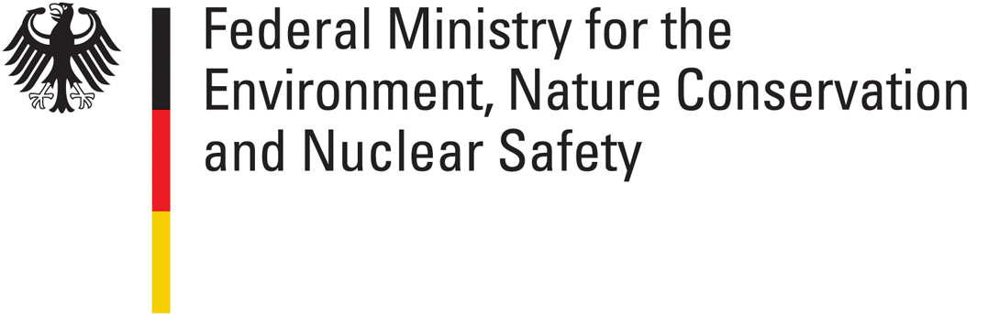
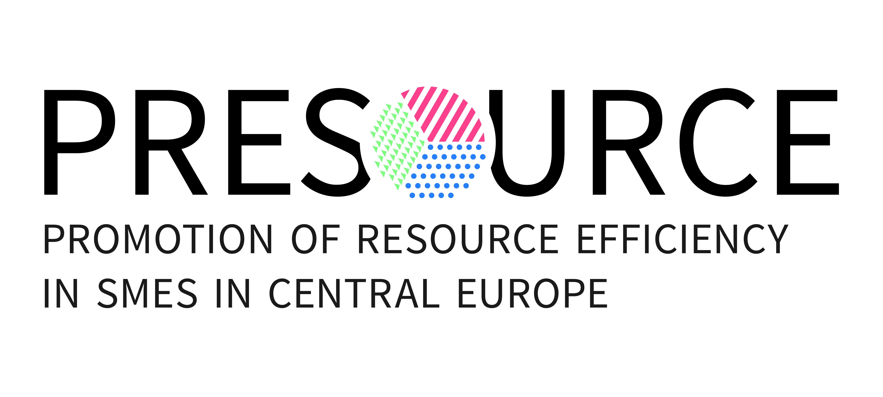

PRESOURCE Transnational Workshops in Berlin

4th and 5th December 2013,

Federal Ministry for the Environment, Nature Conservation and Nuclear Safety, Germany

Draft Agenda as of 7 November 2013-

Wednesday December 4th, 2013

Transnational Workshop on Institutional Support Schemes and Structures for Resource Efficiency in SME

The PRESOURCE project aims at increasing the resource productivity, especially in small and medium sized enterprises (SME) of the manufacturing sector in the countries of Central Europe. PRESOURCE partners have gathered information on relevant actors, their respective activities and support mechanisms in the field of resource efficiency. PRESOUCRE facilitates the exchange of actors on efficient support mechanisms. The information will also be published online on the PRESOURCE competence platform, which will enable intermediaries from public, private and scientific institutions to use this information in their daily work.
The Transnational Workshop is the second in the PRESOURCE project devoted to “Institutional Support Schemes and Structures for Resource Efficiency in SME”. The objective of this workshop is to provide insights into currently implemented support schemes and structures for resource efficiency in SME and to discuss strengths and weaknesses of support mechanisms. One focus of the presentations and the discussions lies on success factors for reaching the final target group, i.e. SME of the manufacturing sector in Central Europe. Public, private and scientific experts in the field of resource efficiency promotion in SME are invited to benefit from and to contribute to the workshop.
Block A of the workshop focuses on support mechanisms at European level, block B focuses on the national and subnational level. Different overviews on existing schemes will be presented, as well as single exemplary projects. Discussions will point to possible further developments, enabling more successful activities.

Moderator tbc
Time | Topic | Responsible PP
9.00 - 9.15 | Registration
9.15 - 9.20 | Welcome by BMU  Ms Birgit Schwenk, Head of Division European and International Aspects of Resource Efficiency, Raw Materials Policy - BMU | BMU
9.20 - 10.00 | Introductory Notes  Challenges and Policies in Supporting Resource Efficiency in Industry in Europe  Ms Imola Bedo - DG Environment, Unit Environment and Industry (tbd)  SME Perspective on Resource efficiency  Feedback from WP 3 survey by ENVIROS | BMU  Enviros (interview results)
10.00 – 12.00 | Block A: EU-level institutional support schemes and structures for resource efficiency in SME
10.00 - 10.15 | Institutional support schemes and structures for Resource Efficiency in SME on EU-level incl. EREP, Agency-Networking  Mr Sebastian Schmidt, VDI ZRE | VDI ZRE
10.15 - 10.30 | Resource Efficiency in the Competitiveness and Innovation Framework Programme (CIP) and succeeding Programmes COSME 2014-2020 and Horizon 2020  Zenit GmbH, CIP National contact point Germany (tbc)/ maybe Projektträger Jülich | BMU/ any suggestions from partners?
10.30 – 10.50 | Resource Efficiency and EraSME: ERA-NET on National and Regional Programmes to Promote Innovation Networking and Cooperation between SMEs and Research Organisation  Dr. Matthias Künzel, Deputy Head of demea – German Material Efficiency Agency | VDI ZRE
10.50 - 11.10 | Coffee Break
- – 11.30 | EU- projects COBALT and DYNAMIX - Decoupling growth from resource use and its environmental impacts  Dr. Martin Hirschnitz-Garbers, Ecologic, project coordinator, tbc | VDI ZRE
11.30 – 12.00 | Discussion of institutional support schemes and structures on EU-level with special focus on improving the access to target groups:  - Strengths and weaknesses of the current structures  - Appropriateness for Central Europe  - Chances of Change (2014-2020)  n.n. , Moderator | All
12.00 – 13.00 | Lunch
13:00 – 17.00 | Block B: National and regional institutional support schemes and structures
13.00 – 13.20 | Support scheme(s)/structure for RE in SME in Hungary  Hungarian Ministry of Rural Development (tbc) | Corvinus
13.20 – 13.40 | Support scheme(s) for RE in SME in the Czech Republic  Ministry of Industry (tbc) | ENVIROS
13.40 – 14.00 | Promoting innovation for material efficiency -  The German Environmental Innovation Programme  Ms Manuela Hammer, UBA (tbc) | UBA
14.00 – 14.20 | The Centre for Resource Efficiency at the German Association of Engineers (VDI ZRE)  Mr Sebastian Schmidt, VDI ZRE | VDI ZRE
14.20 – 14.50 | Coffee Break
14.50 – 15.10 | Support schemes for RE in SME on regional level in Poland  Representative of Ministry or Voivodeship (tbc) | Pro Akademia
15.20 – 15.40 | Support schemes for RE in SME on regional level in Germany  Andreas Kunsleben, Effizienz-Agentur NRW | VDI-ZRE
15.40 – 16.00 | Support schemes for RE in SME on regional level in Austria  Representative of Ministry or (regional) Agency (tbc) | Stenum
16.00 – 16.50 | Discussion of institutional support schemes and structures on national level with special focus on improving the access to target groups:  - Strengths and weaknesses of the support structures and systems  - What could countries from Central Europe learn from each other?  - Could transnational cooperation create synergies?  n.n., moderator
16.50 – 17.00 | Wrap Up and Conclusions  BMU
17.00 | End of the workshop

18 .00 -21.00 Cultural Programme, Get-Together

Thursday December 5th, 2013
Transnational Workshop on Norms, Standards and Indicators for Resource Efficiency in SME
The aim of the PRESOURCE project is to support the increase of resource productivity, especially in the countries of Central Europe. As confirmed by the project partners in their various queries, norms, standards and indicators are important instruments which are used by different actors in their activities aimed at increasing resource efficiency in the manufacturing sector. Public actors usually use macroeconomic indicators to measure the success of policies. Private actors and especially SME use microeconomic forms of measurement to assess their actual situation or their progress in resource-related activities. These forms of measurement can base upon voluntary standards of different types, but also on binding norms.
The aim of this workshop is to give an overview on and to discuss the status quo and current developments concerning norms, standards and indicators for resource consumption and especially resource productivity in countries of Central Europe. Block A focuses on indicators at national level. Thereafter, the workshop concentrates on indicators at the company level in Block B. Different existing forms of measuring resource efficiency will be presented. In block C, the focus will shift to the role of norms and standards for resource use and resource productivity at enterprise level.

Jan Kosmol, UBA tbc
Time | Topic | Responsible PPs
9.00 – 9.15 | Registration
9.15 – 9.20 | Welcome | BMU
9:20 – 12.00 | Block A: Resource Efficiency Indicators at National Level
9.20 – 9.40 | National statistics and resource efficiency indicators – a brief introduction into the status quo and the current discussion  Sven Kaumanns, DESTATIS Federal Statistical Office of Germany (tbc) | BMU
9.40 – 10.00 | National resource indicators of the Austrian Government – The bottom up approach and lessons learned  Representative of Ministry or (regional) Agency (tbc) | STENUM
10.00 – 10.20 | Coffee Break
10.20 – 12.20 | Block B: Resource Efficiency Indicators at enterprise level
10.20 – 10.40 | The EU pilot phase for Product and Organisation Environmental Footprints  Pavel Misiga, Head of Unit Eco-Innovation & Circular Economy, DG Environment (tbc) | Enviros
10.40 – 11.00 | Environmental Footprinting for SME – Practical Expertise  Representative of ENEA, Italy (tbc) | ENEA
11:00 – 11:20 | Resource efficiency indicators as basis for investment decisions – Lessons learnt from more than 90 interviews with public and private investors  Dr. Robin Bürger, MOEZ Fraunhofer | MOEZ
11.20 – 11.40 | Resource indicators in environmental management schemes  n.n., German EMAS Advisory Board | UBA
11.40 – 12.15 | Discussion of links between macro- and micro - level indicators; what to learn from other indicator debates  n.n., moderator
12.15 – 13.00 | Lunch
13.00 – 15.00 | Block C: Norms and standards
13.00 – 13.20 | Resource efficiency through standards and norms ?– an introduction and (critical) assessment of the role of standards and norms  n.n., Öko-Pol (tbc) | BMU
13:20 – 13.40 | VDI – Technical Guidelines as an example for ways to harmonise approaches to measure resource use in SME  n.n., VDI Guideline Committee | VDI-ZRE
13.40 – 14.00 | Example of national approach to resource efficiency in norms and standards  n.n., Hungarian Standard Organisation | Corvinus with hint from Enviros
14.00 – 14:20 | Coffee Break
14:20 – 14:40 | Exemplary approach to resource efficiency measuring standards and their application  CDP Germany (tbc) | BMU
14.40 – 14.55 | Discussion of norms, standards and indicators for RE in SME in Central Europe  - Are existing indicators sufficient to measure RE in SME? What are their weaknesses; what are strengths?  - … | All, Moderation by s.pro/ UBA
14.55 – 15.00 | Wrap Up, and Outlook | UBA/ BMU
15.00 | End of the workshop

About PRESOURCE
The Policy Background
The topic of resource efficiency or productivity has reached a high importance in politics and business. Evidence on its past performance indicates that the EU’s response must go beyond existing policy action. Consequently the European Commission put resource efficiency at the heart of its structural economic strategy.
Resource Efficiency is one of the 7 Flagship Initiatives of the Europe 2020 Strategy. It is complemented by an EU Roadmap to a Resource Efficient Europe, which provides the strategic framework for future action and calls for an integrated approach across many policy areas at European, transnational and national levels.

The Challenges and Barriers
The EU12 countries (and most Central European partner countries belong to the New Member States) have a dramatically lower material productivity than the EU15 or the EU27 average (581 compared to 1304 USD/ton). This has been revealed by a survey conducted by the European Environment Agency in 2011. And the trend is even more alarming: While the material productivity in the EU15 has been increased constantly since 2000, the productivity in the EU12 has remained static or even decreased.
This calls for immediate action in Central Europe. It will be crucial for enterprises in the region to increase their material productivity and - in a wider sense - resource efficiency in order to keep or even increase their competitiveness.

Two major barriers for exploiting the potential for resource efficiency in products and production processes can be identified:
• Enterprises and especially SMEs are not aware of their resource utilization, real costs of non-product outputs and the related (cost) reduction potential as well as means to improve it.
• SMEs have problems in financing necessary investments in eco-innovations in order to exploit their potential to increase resource efficiency.

What is PRESOURCE about?
PRESOURCE aims at the achievement of the following results:
1. Improved in-house capacity (managerial and technological): We want to enable SMEs in the production sector to identify and exploit within their own organization potential for increasing the resource efficiency of the production process and products – for the benefit of economy & environment.
2. Improved knowledge and mechanisms for risk sharing and for financing eco-innovations in SMEs: We will provide incentives and innovative financing schemes for external and internal investment decisions.
3. Improved framework conditions: We want to enable policy makers, intermediaries and multipliers in CE to respond to the EU Roadmap.

PROJECT PARTNERS
Germany: Federal Environment Agency, Federal Ministry for the Environment,
Nature Conservation and Nuclear Safety, Fraunhofer Center for Central and Eastern Europe
Czech Republic: ENVIROS Ltd.
Poland: Research and Innovation Center Pro-Akademia
Austria: STENUM Environmental Consultancy and Research Company Ltd.
Italy: ENEA –National Agency for New Technologies, Energy and Sustainable Economic Development
Hungary: Corvinus University of Budapest

PROJECT DURATION June 2012 – November 2014

Practical Information

Meeting venue:  How to get there: | Federal Ministry for the Environment, Nature Conservation and Nuclear Safety  Room KTR 03.07.01  Köthener Straße 2–3  DE–10963 Berlin  Contact: Janka Clauder (Tel. +49-30-28550-2379)  From Tegel airport (TXL):  Public transport: From Tegel airport, take Bus TXL (direction: S+U Alexanderplatz) and get off at S+U Brandenburger Tor. Take metro S 1 (direction: S Wannsee) and get off at S+U Potsdamer Platz.  Taxi: approx. 25 EUR  From Schönefeld airport (SXF):  Public transport: From Schönefeld airport, take metro S45 (direction: S+U Bundesplatz) and get off at S Südkreuz. Take Metro S2 (direction: S Buch) to S+U Potsdamer Platz.  Taxi: approx. 35 EUR  From Berlin Hauptbahnhof (central station):  Public transport: Take bus M41 (direction: Sonnenallee/ Baumschulenstraße) and get off at S+U Potsdamer Platz.  Alternatively, take metro S 5 (direction: Strausberg), S 7 (direction: Ahrensfelde) or S 75 (direction: Wartenberg) and get off at S+U Friedrichstraße. Change for metro S 1 (direction: Wannsee) or S 2 (direction: Blankenfelde) and get off at S+U Potsdamer Platz.  Taxi: approx. 10 EUR

